Chang Sensory Trails, a Thai food experience inspired by chef memories,
is starting its 2017 world tour in London

This culinary adventure, curated by renowned chef couple Chef ‘Bo’ Songvisava and Chef Dylan Jones, will take place at Old Spitalfields Market on the 29th April

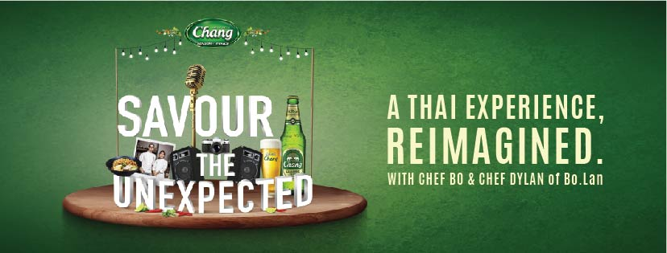

LONDON, United Kingdom, 31 March 2017 — Thailand’s leading beer brand, Chang, will be at London’s Old Spitalfields Market this April to host Chang Sensory Trails, a multi-sensorial playground centered on iconic Thai flavours.

Building on last year’s success, Chang Sensory Trails is back for a second year running, kicking off its 2017 global campaign in London, before travelling to San Francisco and Singapore. This free to enter, un-ticketed event is coming to London on the 29th of April and aims to deliver ‘the unexpected’ by introducing the world to a modern, refreshing take on Thai food, art and music.

At Chang Sensory Trails, there is a story behind every bite. Curated by Chef Bo and Chef Dylan, the duo is eager to share with visitors a unique culinary journey inspired by their fondest memories.

Awarded Asia’s Best Female Chef 2013, Chef Bo is a hugely influential figure in Thai cuisine. Driven by the belief that the best Thai restaurants should be found in Thailand, her restaurant Bo.Lan, co-founded with her husband Chef Dylan, recently placed 19th at Asia’s 50 Best Restaurants 2017. The couple met while working at David Thompson’s Nahm, the first Thai fine dining restaurant to ever receive a Michelin Star.

Fiercely passionate about sustainable food practices, Bo and Dylan work closely with local farmers, advocating bio-diversified produce as reflected in Bo.Lan’s ever-changing menu, with the aim of achieving zero carbon footprint for their restaurant by 2018. Sharing this same commitment to eco-friendliness, Chang Sensory Trails will only be using biodegradable serve ware at the event.

What not to miss:
Taste
London’s finest Thai restaurants are teaming up with the chef couple, offering up their own tantalizing selection of dishes, as inspired by Bo and Dylan’s memories. With no shortage of fresh and bold flavours, visitors will be hard-pressed to pass on this stellar lineup:

- Patara, Plaa Salmon
“Before working in London, I took a trip to Thailand, thinking I would spend six months learning all I could about the local cuisine, but after tasting this dish, my interest in Thai food became a full-blown obsession! In the end, my holiday lasted five years.”

- Busaba Eathai, Thai Calamari
“These crispy glazed calamari are a personal favourite for us. On an early trip to meet with the fishermen who catch our sustainable seafood, we had the opportunity to eat the freshest of prawns straight from the ocean. These were of course accompanied by a nahm pla prik.”

- Regional Thai Taste, Chor Muang
“This steamed Thai dumpling dish reminds us of our first trip to Isaan to source the amazing organic rice that we use at our restaurant. We spent two days in the fields with the farmers planting the rice. In the evening, the women would get together and create the most rustic but flavorful food.”

- Farang, Smoked Salmon Mee Krob
“Over the years, we’ve built an amazing relationship with our farmers. We can never forget the first time one of them led us to her own private garden just behind the farm. There she proudly showed off her collection of Thai vegetables and flowers which we simply couldn’t resist making into a salad. This smoked salmon, yellowbean, mandarin and crispy noodle is a great reflection of that.”

- 101 Thai Kitchen, Somtum and Southern Style Fried Chicken
“Aside from my professional mentors, my dad is one of the big figures in my life that has shaped the way I think about my cooking. When I was younger, I’d often cook with him and he’d encourage me to come up with my own ways of cooking the same dish, one of which was friend chicken.”

- Janetira, Khao Soi Gai
“When it comes to cooking, in many cases the teacher knows best. The first time I made this dish for my mentor, she taste one spoonful and knew exactly where I learned this from.”

- Tawana, Moo Yang Jim Jael
“I often say that the way to your wife’s heart is through their stomach! Whilst we were still dating, I had a go-to list of Thai dishes that were her absolute favourite and this was one of them. I still cook this one often at home – more so I can skip on doing some house chores.”

Win a seat at the exclusive Chef’s Table
Anyone can win the chance to savour a special menu and intimate VIP experience with Chefs Bo and Dylan at the Chef’s Table. The husband and wife team will be personally presenting their interpretations of iconic Thai dishes in a single “course-prohibited” serving, promoting the Thai tradition of sharing food amongst the table.

VIP Chef’s Table tickets will be given away on Chang Beer’s Facebook page, UK Twitter profile, @ChangBeerUK and Instagram profile, @changbeeruk — those interested should like and follow for details using #ChangSensoryTrails.

Sounds, sights and smells
Not confined to just fantastic tastes and smells, Chang Sensory Trails will promise to be a feast for all the senses. The event will feature great tunes to set the vibe, including Live Lounge — who will be performing their versions of songs performed on Radio One’s famous slot of the same name.

Visitors can also expect to explore and scale the “Herb Hill”, an aromatic art installation built on the foundations of Thai cooking – its iconic ingredients.

With live music, interactive art, delicious food and refreshing drinks, Chang Sensory Trails is the perfect recipe for a memorably entertaining evening, one best enjoyed with friends. Experience the event between 12pm and 10pm on the 29th April, while everyone can join the celebrations online at:

Facebook: www.facebook.com/changbeer/
Twitter: @ChangBeerUK
Instagram: @changbeeruk
Official hashtags: #ChangSensoryTrails and #ChangBeer

- End –

Notes to editors:
Media interviews are available with Bo Songvisava and Dylan Jones prior to the event, as are spaces on the Chef’s Table at the event. Please contact Lucre PR for more information.

Media contacts – Lucre PR
Philly Barker / Rhys Reynolds / Laura Duncan / Jack Moore
Chang@Lucre.co.uk
0208 741 5900
About Chang Beer

Chang Beer was first introduced in Thailand in 1995, and within three years it had already captured over 50% of the Thai market.

Chang Beer is a well-balanced and full-bodied lager with a complex aroma and a crisp, smooth and incredibly refreshing taste.

Chang uses deep-well water to achieve the perfect mineral composition to brew its lager, water so pure it is also bottled and sold in Thailand as mineral water.

Chang is synonymous with the taste of Thailand for many of its international fans. It is also well-known as the long-term sponsor of Everton Football Club.

